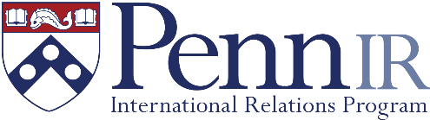 | Penn International Relations Program  Summer Funding Application

The International Relations Program at Penn has some limited funding available to support students who are pursuing an unpaid (or significantly underpaid) internship, especially those pursuing internships with the federal government, or other public sector entities (including IGOs).

You should also apply to other sources of funding. Office of Career Services has its own Summer Funding Program (https://careerservices.upenn.edu/career-services-summer-funding-program/), and Highly Aided Students should apply to the Highly Aided Summer Funding Program (https://srfs.upenn.edu/financial-aid/highly-aided/summer)

To apply, fill out the following form and attach the required documents, and email to Dr. Nishino (tnishino@sas.upenn.edu),

Name: ___________________________
Penn ID: ___________________________
Year/Graduating Class: ___________________________

Are you applying to other sources of funding? If yes, which ones?
__________________________________________________________________________________________

Are you a Foreign Student (F-1 Visa)? If yes, have you made CPT arrangements? ____________________

Internship Information:
- Employer: ___________________________
- Employment dates: ___________________________
- Is this full time (minimum 30 hours/week)?___________________________
- Is this a paid position?___________________________
- Is this in-person or remote?___________________________
- Title/Role/Position & Department/Organization:__________________________________________
- Expected responsibilities: _____________________________________________________________

Please attach:
- Resume/CV
- Copy of Internship Offer Letter
- Expected Budget (see guidelines on webpage)

Statement of Purpose (no more than 500 words):
- How does this position align with your studies as an IR major?
- What do you hope to learn from this position in terms of specific skills/knowledge, and how does it align with your career goals?

